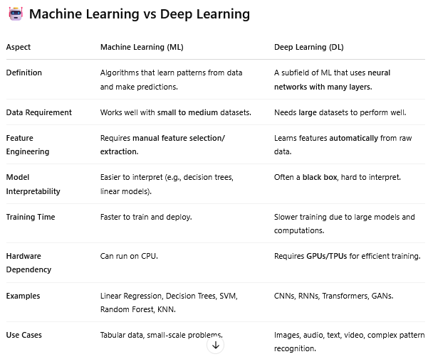

--------------------------------------------------------------------------------------------------------------

**Why Deep Learning is Often More Accurate**

1. Automatic Feature Learning

* DL models learn high-level representations from raw input (e.g., edges → shapes → objects in images).
* No need to manually engineer features.

2. Non-linearity and Complexity

* Neural networks can model very complex, non-linear functions.
* Useful in tasks where patterns are too complex for traditional ML (e.g., image classification, language translation).

3. Scalability with Big Data

* The more data you give to deep models, the better they get — unlike ML models, which plateau.

4. End-to-End Learning

* Deep learning often replaces multiple stages of pipelines (e.g., in NLP, it replaces tokenization, feature extraction, modeling).

5. Transfer Learning & Pretrained Models

* Use of pre-trained deep models (like ResNet, BERT) gives a huge boost in accuracy even with limited data.

⚖️ So, should we always use deep learning?

Not necessarily!

* If you have small structured data (like a CSV file), traditional ML models like XGBoost or Random Forest often outperform deep learning.
* If your problem involves images, text, speech, or very large and complex datasets, deep learning will likely outperform ML.

✅ TL;DR:

Deep learning = more accurate on complex, large-scale problems — because it learns powerful features directly from raw data with high-capacity neural networks.